**Design Document**

**for**

**Software Design Project**

**Version 1.0**

**Prepared by: Gonul Kilic**

**Pooja Khare**

**Edward Ai**

**Surabhi Trivedi**

**Table of Contents**

1. INTRODUCTION

1 1.1 Purpose

1.2 Scope

1.3 Overview

1.4 Reference Material

1.5 Definition and Acronyms

2. SYSTEM OVERVIEW

2.1 Assumption

2.2 Constraints

2.3 System Environment

2.4 Design Methodology

3. SYSTEM ARCHITECTURE

3.1 Architectural Design

4. DATA DESIGN

4.1 Data Description

4.2 Data Dictionary

4.3 Class Diagram

5. COMPONENT DESIGN

5.1 Administrator

5.2 Manager

5.3 Student

6. HUMAN INTERFACE DESIGN

6.1 Overview of User Interface

6.2 Screen Images

6.3 Screen Objects and Actions

1. **INTRODUCTION**
   1. **Purpose**

The purpose of this document is to describe how architecture and implementation of Software Development Project. The Software Requirement Specification for Software Development project is the main source for this document. However, the intended audiences for this document are mainly software developers if there is any need to maintenance project also Building Administrator can use this document.

* 1. **Scope**

The scope of this document is to describe the implementation details of the Software Development. This Software will consist of three major roles. First would be the Admin who would be creating the forms and assigning the roles to the manager and the technician, the second would be the Manager who would be assigning the role to the technician, and the technicians would be adding data in the form and uploading it

* 1. **Overview**

This document has been created according to the IEEE Recommended Practice for Software Design Descriptions. Document will have 8 sections as can be seen on Table of Contents.

* 1. **Reference Material**

1. Software Development Project / Software Requirement Specification Document
2. IEEE Recommended Practice for Software Design Descriptions
   1. **Definitions and Acronyms**
3. **SYSTEM OVERVIEW**

This document is written according to the “IEEE Recommended Practice for Software Design

Documentation”. This software design document is divided into 8 sections with various subsections. The sections of the Software Design Document are as follows:

1. Introduction

2. System Overview

3. System Architecture

4. Data Design

5. Component Design

6. Human Interface Design

7. Requirements Matrix

8. Appendices

1. **SYSTEM ARCHITECTURE**
   1. **Architectural Design**

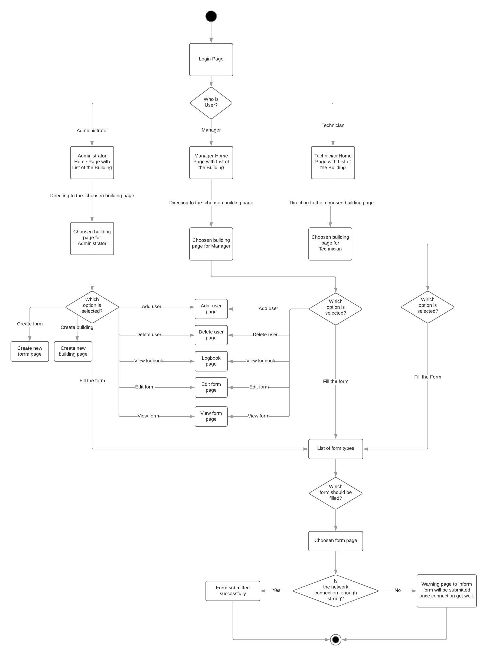

The diagram above consists of:

* + The functionalities of the system based on user authorization.
  + Workflow of the system.
  + Backend system controls.
  1. **Decomposition Description**

The application is divided into three layers that is MVC. At first it will get Request from system to Controller then controller will access data from Model and will View data from Controller and Controller will respond as HTML files to system.

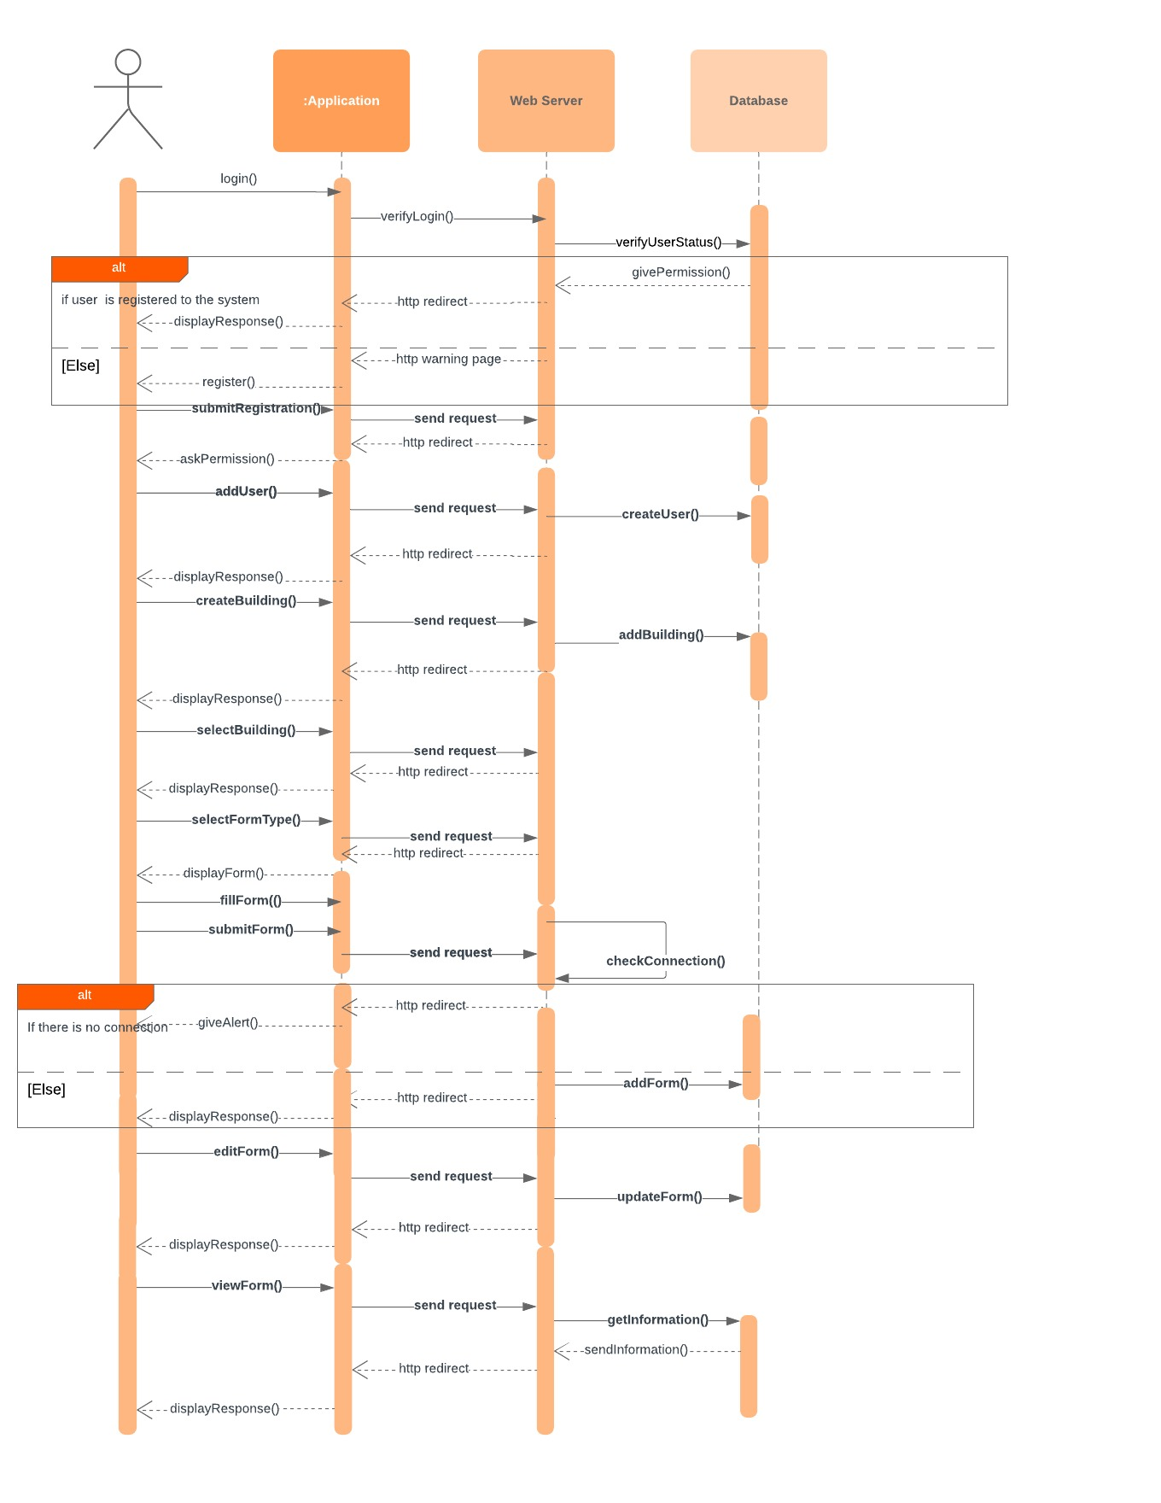

The sequence diagram above shows;

* + The relationship between the object of the system.
  + The process of the functionalities from the backend part of the system.
  1. **Design Rationale**

Design Rational The design also hinges on network access. If there is no network access available, the client systems will not be able to send or receive any data. This is acceptable, as the projected size of the database will exceed the space limits on almost all of the clients.

1. **DATA DESIGN**
   1. **Data Description**

XAMPP and PhpMyAdmin Control Panel database communicate with the database which is installed locally on the server.

* 1. **Data Dictionary**

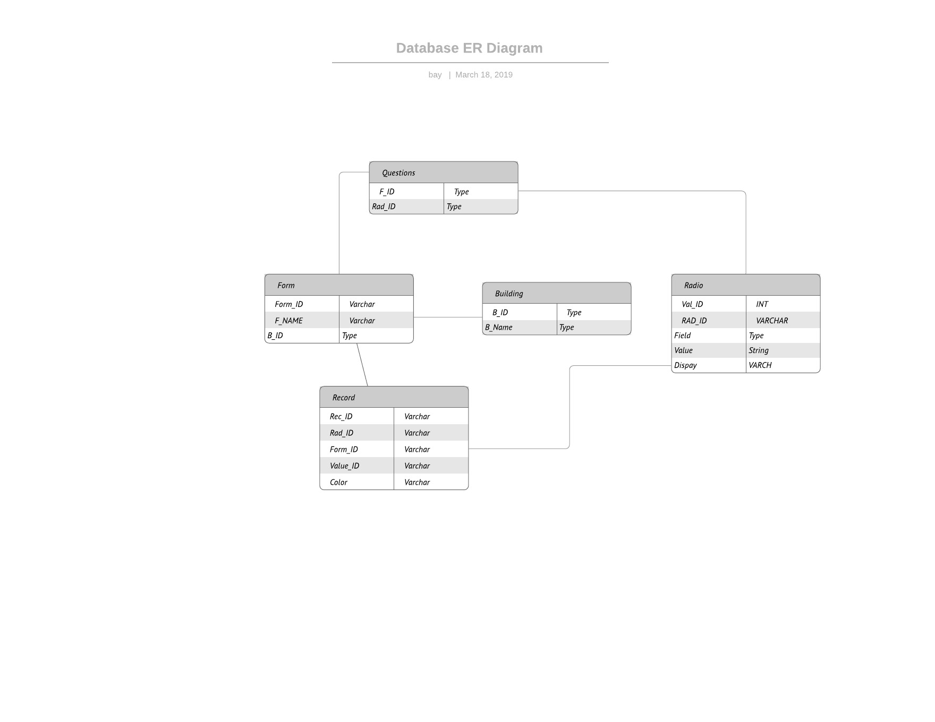

1. **COMPONENT DESIGN**

**5.1 ADMIN**

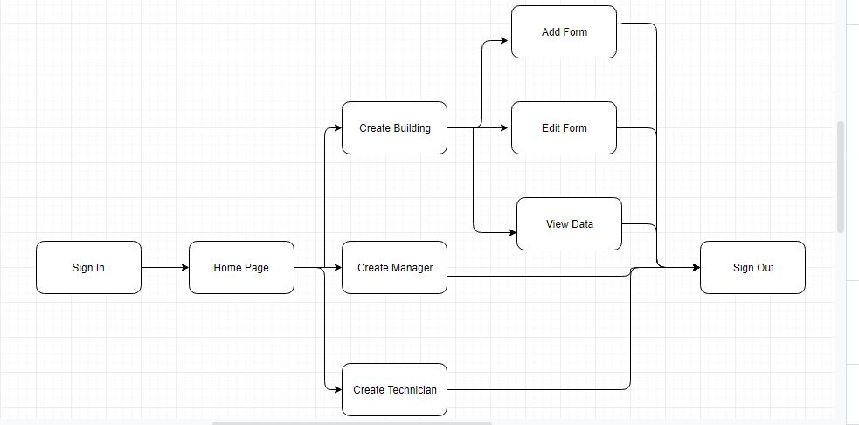

**5.2 MANAGER**

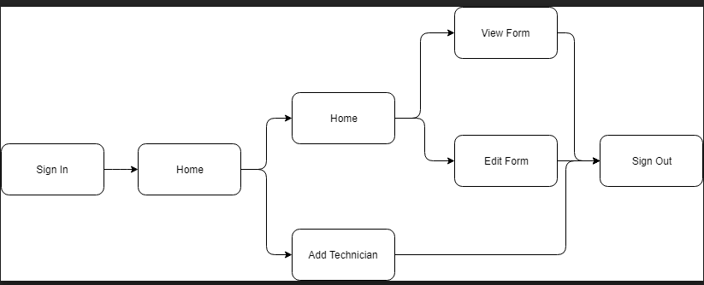

**5.3 TECHNICIAN**

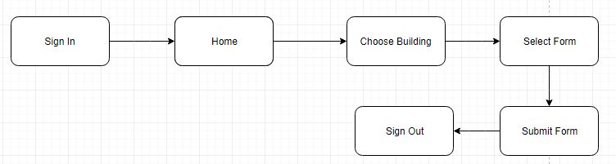

1. **HUMAN INTERFACE DESIGN**
   1. **Overview of User Interface**

Describe the functionality of the system from the user’s perspective. Explain how the user will be able to use your system to complete all the expected features and the feedback information that will be displayed for the user.

* 1. **Screen Images**

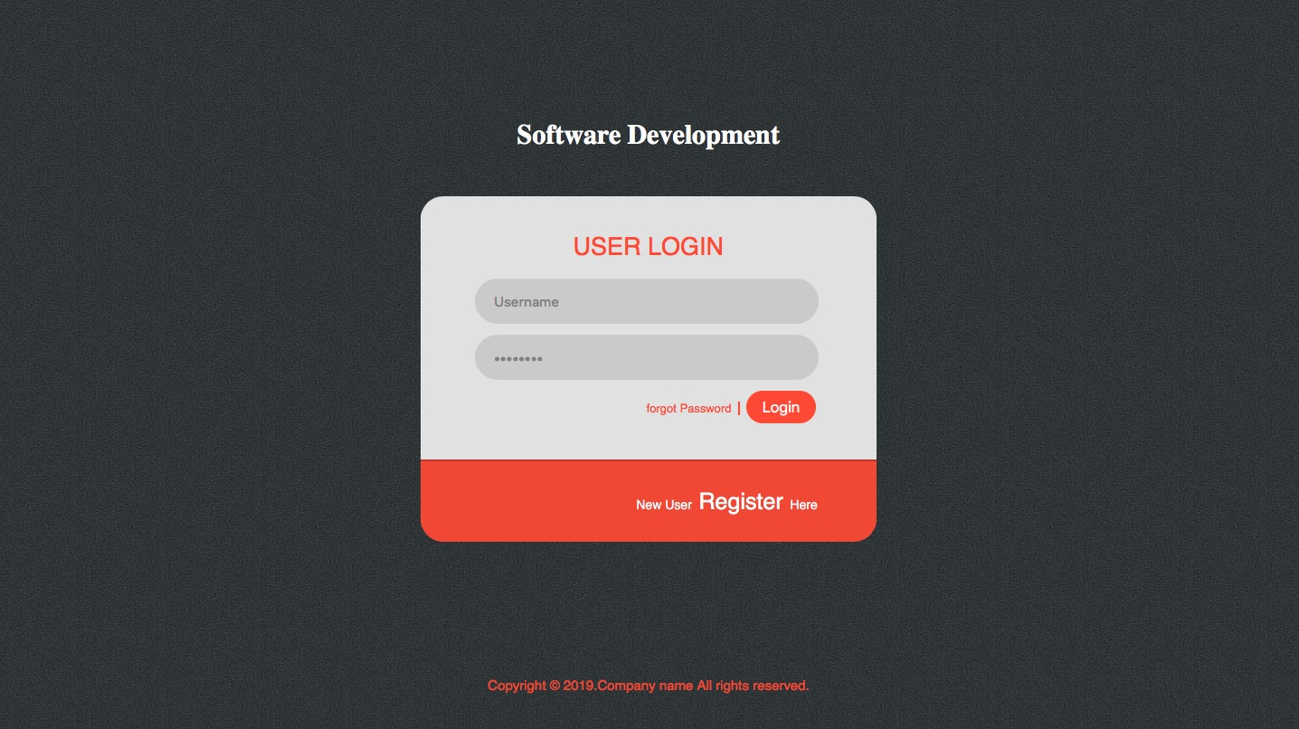

* 1. **Screen Objects and Actions**

There are three dashboards in the system and the general structure of the user interface is as follows: There exist 2 main tabs on the top of the dashboard 1 is the home button which would get the user to the home button of the user’s page. And the second is the sign-out here the session would be ended and the user who is signed in is signed out of the system.

When the Admin logs in he can see the option of creating the new building. He can create multiple building and the buildings would be displayed on the same page in the synchronized manner.

When the Admin clicks on the building, he would have following options such as create Manager, Create Technician, Create Form and View Data. Create Manager would create a Manager of that following building, create technician would create Technician for the building, create form would allow the Admin to create the form the way he wants to collect the data. And view data would allow the admin to view the data uploaded by the technician.

When the Manager logs in he would be having the options of creating the Technician editing the form of the building he is assigned and viewing the data of the building he is assigned to work on.

When the Technician logs in the system he would be having access to the multiple forms of the building assigned to him. So when he selects the forms he would be allowed to enter the data inside the form and submit the data entered by him.